Representative:

Submit Requisition to Store

After department representative log in, submit requisitions to store will show as default screen.

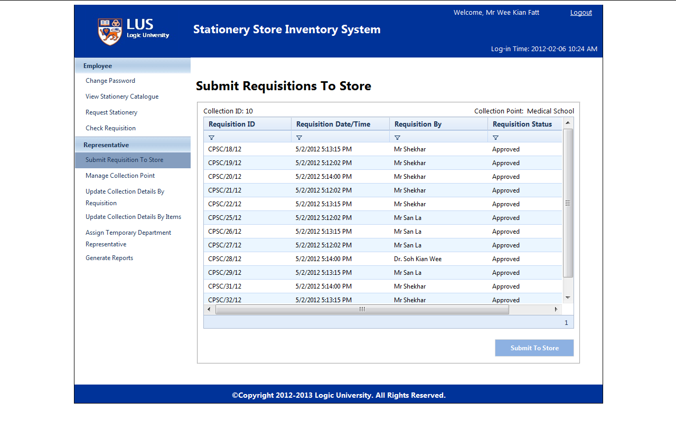

Click “Submit” then system will automatically send requisition to Store

